
RAMAIAH
INSTITUTE OF TECHNOLOGY
USN | 1 | M | S

(Autonomous Institute, Affiliated to VTU)
Bangalore – 560 054

SEMESTER END EXAMINATIONS – MAY/JUNE 2017

Course & Branch | : | B.E : Information Science and Engineering | Semester | : | IV
Subject | : | Design and Analysis of Algorithms | Max. Marks | : | 100
Subject Code | : | IS414 | Duration | : | 3 Hrs

Instructions to the Candidates:
- Answer one full question from each unit.

 |  | UNIT - I
1. | a) | Explain various asymptotic notations used to represent the rate of growth of run time of algorithms with one example for each. | CO1 | (10)
 | b) | Why worst case analysis of algorithms is more important than average case analysis? | CO1 | (04)
 | c) | Explain important fundamental problem types of different categories. | CO1 | (06)
2. | a) | Explain the method of comparing the order of growth using limits. Compare order of growth of following functions:  (i) 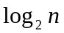& 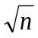 (ii) ()² & 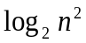 | CO1 | (10)
 | b) | Discuss the various stages of algorithm design and analysis process using flow chart. | CO1 | (10)
 |  | UNIT - II
3. | a) | What is Brute Force approach? Write a Brute force string matching algorithm. Using the same, determine the number of character comparisons in searching for the pattern “NOT” in the text “NOBODY_NOTICED_HIM”. | CO1 | (06)
 | b) | Describe divide and conquer design technique. Design an algorithm for implementing merge sort using the same. | CO1 | (10)
 | c) | Solve the recurrence C_{worst}(n)= C_{worst}()+1 for n>1, C_{worst}(1)=1, for n=2^{k} by backward substitutions. | CO1 | (04)
4. | a) | Write an algorithm to sort a given set of elements in ascending order using Quick sort method. Sort the following list of elements using the same {C,O,M,P,U,T,I,N,G} | CO1 | (08)
 | b) | Apply Horspool string matching algorithm to search for the pattern BAOBAB in the text BARD LOVED BANANAS. | CO2 | (04)
 | c) | Write a recursive algorithm to find the height of a binary tree and analyze the same. | CO1 | (08)
 |  | UNIT - III
5. | a) | Solve the following Knapsack problem using dynamic programming technique. Given Knapsack capacity W=8.  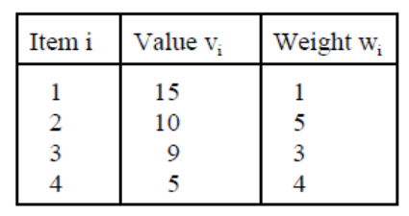 | CO2 | (10)
 | b) | Discuss Greedy technique. Consider the five character alphabet {A, B, C, D, E} with the following occurrence probabilities:  Construct the Huffman tree and generate the resulting code word for each alphabet. | CO2 | (10)
  Character | A | B | C | D | E
  Probability | 0.50 | 0.25 | 0.40 | 0.50 | 0.75
6. | a) | Discuss Floyd’s approach to find all pairs shortest path and apply the same to solve the following all pairs shortest paths problem.  Derive the time efficiency of the algorithm. | CO1 | (10)
  0 | 3 | 8 | ∞ | -4
  ∞ | 0 | ∞ | 1 | 7
  ∞ | 4 | 0 | ∞ | ∞
  2 | ∞ | -5 | 0 | ∞
  ∞ | ∞ | ∞ | 6 | 0
 | b) | Define the term minimum spanning tree. Apply Kruskal’s method to find minimum cost spanning tree for the following graph:  Edge weights: ab=4, bc=8, cd=7, de=9, ef=10, fg=2, ig=6, ih=7, hg=1, ah=8, df=14, bh=11.  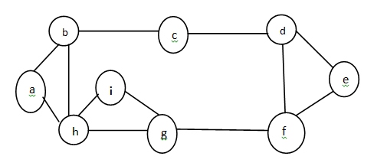 | CO1 | (10)
 |  | UNIT – IV
7. | a) | Define AVL tree. Explain the various types of rotations that can be performed to balance the tree. Construct AVL tree for the given list of elements: 60, 1, 10, 30, 100, 90, 80. | CO1 | (10)
 | b) | Design an algorithm for BFS. With an example graph, explain the working and applications of the same. | CO1 | (10)
8. | a) | Define transform and conquer technique and variants. Design an algorithm to sort the elements using Insertion sort and trace the same on the data set 5, 3, 1, 9, 8, 2, 4, 7. | CO1 | (10)
 | b) | Define 2-3 tree. For any 2-3 tree of height h consisting of n nodes, prove the following:  log₃(n+1)-1 ≤ h ≤ log₂(n+1)-1  Construct 2-3 tree for the list 9, 5, 8, 3, 2, 4, 7. | CO1 | (10)
 |  | UNIT - V
9. | a) | Differentiate between back tracking and branch-and-bound design techniques. | CO1 | (05)
 | b) | Briefly explain the concepts of P, NP and NP complete problems with one example for each. | CO3 | (05)
 | c) | What is backtracking design technique? Find the solution to 4-Queens problem using state space tree for all the solutions. | CO2 | (10)
10. | a) | What is approximate algorithm? A transportation network for 5 cities is given below along with the distance between the cities. Write approximate algorithm to solve the travelling salesman problem and apply the same on the following graph and compute accuracy ratio. (consider ‘a’ as source vertex)  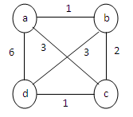 | CO3 | (10)
 | b) | What is heap? Write the bottom-up heap construction algorithm and analyze its worst-case time efficiency. | CO1 | (10)
****************

